MEDICAL WOMEN’S FEDERATION
NOMINATION FORM FOR THE POSITION OF

Date:

Name of nominee:

Region / Local Group:

Address:

Proposed:

Signature
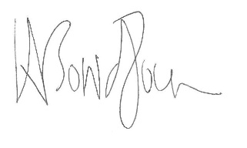

Seconded:

Signature

Nominee’s signature:

